|  |  |
| --- | --- |
| Time domain response | Frequency domain response |
|  |  |

1. One of the key points of this exercise is to find frequencies of two or more sinusoids are multiplied or summed.
2. Find the following sinusoidal multiplications using Euler’s identities.
3. 
4. 
5. 
6. Now plug in if the value of , find the frequencies after the multiplications
7. Plot frequency responses of b) in magnitude and phase.
8. I recommend using tools (Matlab, octave, python, etc…) to plot the frequency responses and the ranges of the frequencies are 
9. Plot  in magnitude and phase. (it means frequency response of rectangular function with amplitude 2, center at 0, and width of 4)
10. Plot  in magnitude and phase.
11. Plot  in magnitude and phase.
12. What is the difference between a) & b) in the frequency domain? Compare magnitude vs. magnitude & phase vs. phase of two signals in the in the frequency domain.

The angle  is in degrees.

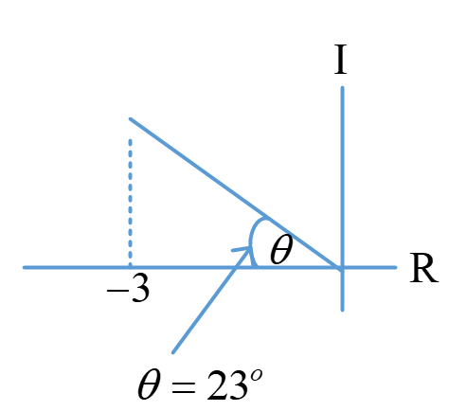

1. Write given plot in rectangular form. 
2. Write given plot in polar form (in radian) 

Convert the following function in polar form.

1. 
2. 
3. For the given sinusoid figure below, determine amplitude (A), period , frequency , and phase .
4. Write this figure in terms of **sine & cosine** function using RMS (do you remember how to represent RMS (root mean square) values.-or you can verity with simple calculation)
5. And also represent this function in terms of exponential function too (You know that )

